**CLOUD SERVERLESS COMPUTING**

Integration of LEX bot with a web application using Kommunicate

STEP 1 : LOG IN TO AWS MANAGEMENT CONSOLE

STEP 2: GO TO SERVICES TAB AND SEARCH FOR AMAZON LEX AND CLICK ON IT

STEP 3: CREATE A CHATBOT WITH NAME NEW PROJECT7 AND CREATE INTENTS

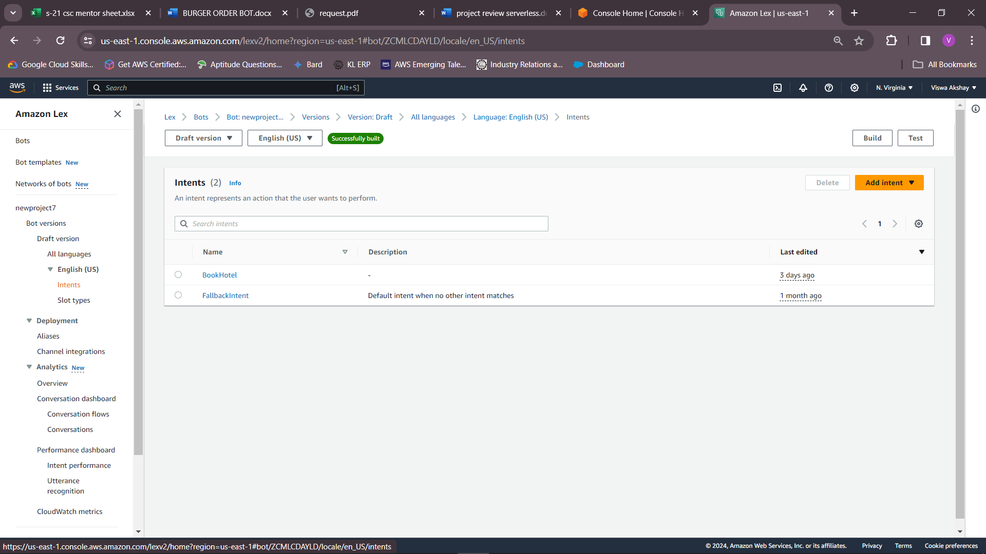

STEP 4: CREATE THREE NEW SLOT TYPES

STEP 5: CREATE A SLOT HIGHTS

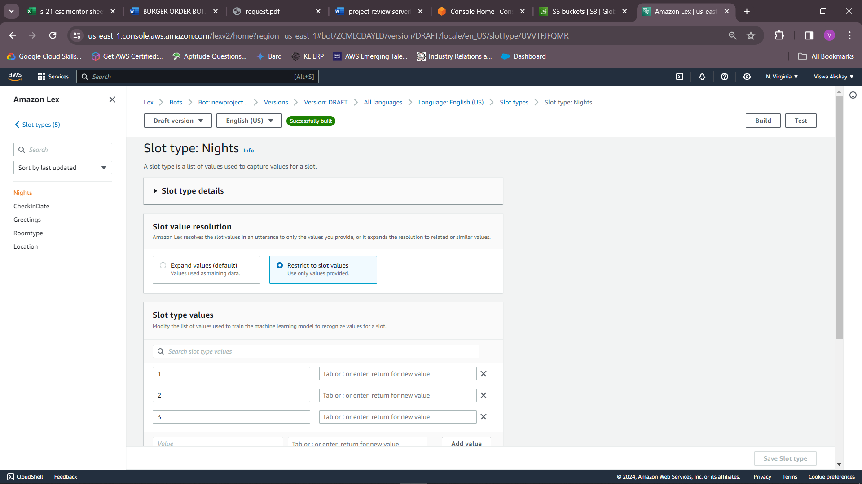

STEP 6: CREATE A SLOT CHECKIN DATE

STEP 7: CREATE A SLOT ROOMTYPE

STEP 8: CREATE AN SLOT LOCATION

STEP 8: CREATE AN SLOTS

STEP 9: ENTER CONFIRMATION AND FULFILMENT

STEP 10: DEPLOY THE LAMBDA FUNCTION

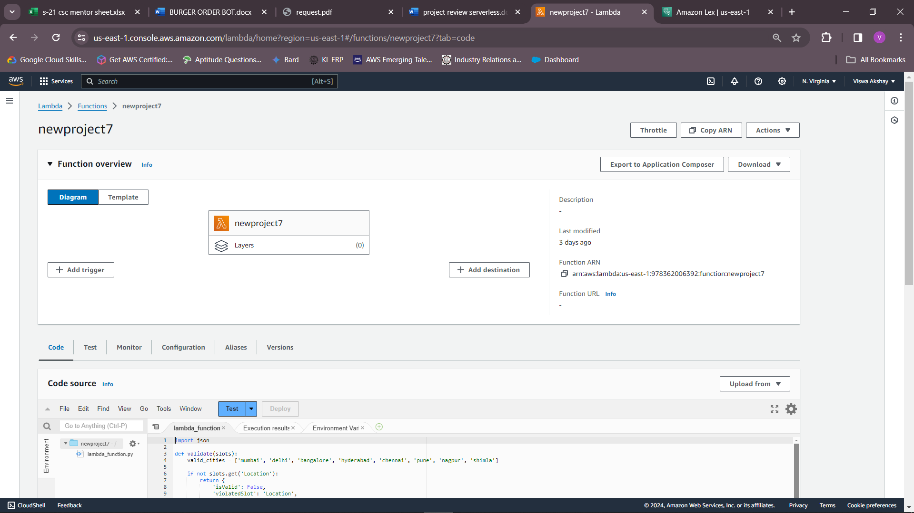

STEP 11: LAMBDA TRIGGER IN LEX

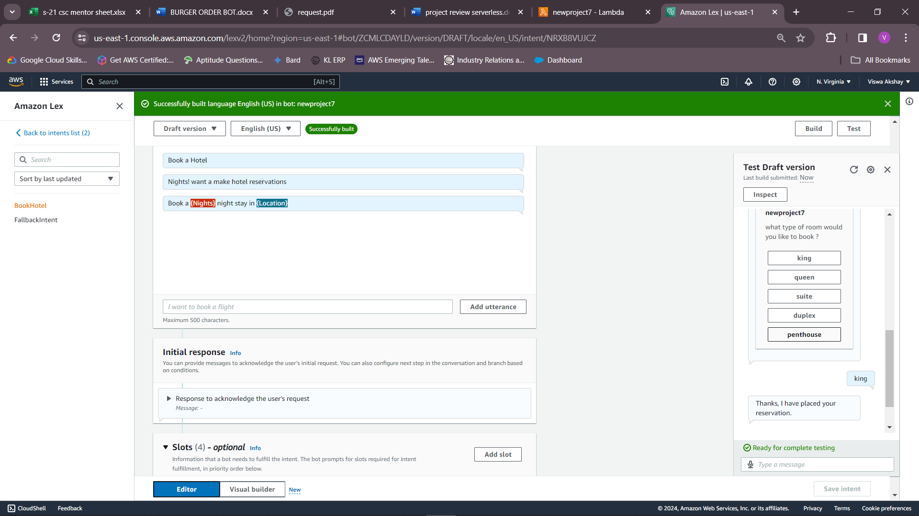

STEP 12: CREATE A HTML PAGE

STEP 13: INTEGRATE THE HTML PAGE WITH THE AWS CHAT BOT THE FINAL OUTPUT:

